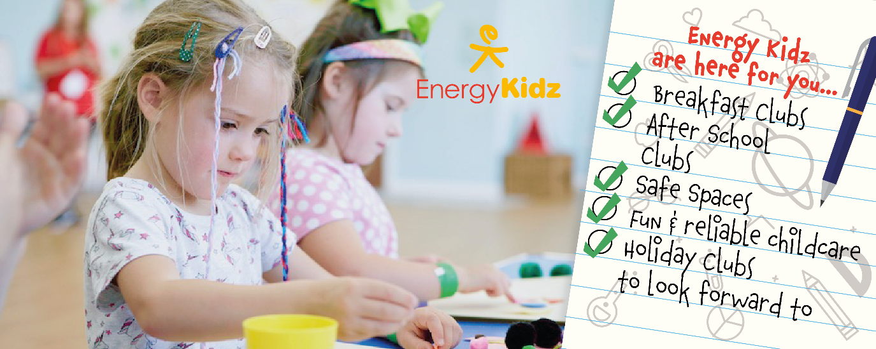

Energy Kidz will continue to be here for you throughout lockdown
with our Term Time School Clubs!

In light of the recent government announcement regarding the new lockdown measures across the UK – Energy Kidz would like to extend their best wishes to all families during these uncertain times and would like to reassure parents and families that as the Trusted Childcare Provider throughout the pandemic and after liaising with your school, they are delighted to confirm that Energy Kidz Clubs are still here for you this Autumn Term as they continue to operate safely at our school.
The health and wellbeing of children has never been more important than now. With many facilities unavailable – Energy Kidz are determined to continue having a positive impact on children’s lives as their action packed services remain available to families throughout the impending lockdown and beyond.

You can secure your spot for the second part of the Autumn Term at their Term Time Club and give your child something to look forward to by securing a spot at their highly anticipated Winter Camps at https://www.energy-kidz.co.uk/. Find out more below!

A Word from Energy Kidz…

Our work with the DFE and continued operation throughout various stages of lockdown has allowed us to develop market leading safe practice which provides children with invaluable experiences that enable every child to get active whilst empowering them with an enhanced sense of wellbeing and confidence. Following the recent government announcement – childcare services and schools remain open! Therefore, Energy Kidz Clubs will continue to deliver fundamental child experiences that have proven to not only keep children safe but ensure children can access integral social, physical and mental childhood experiences, socially, in a fun and engaging environment.

Don’t let your child miss out on Term Time School Clubs this Winter…

As the UK’s Trusted Provider throughout the pandemic we are determined to continue supporting children with safe spaces to enjoy an engaging environment that provides opportunities for valuable social interactions and fun packed activities to be enjoyed with friends in a club setting. To ensure your child doesn’t miss out this November, we encourage all our parents to book their child’s place at their Term Time school club today! Don’t let your child miss out on all the benefits an Term TIme School Clubs can bring... 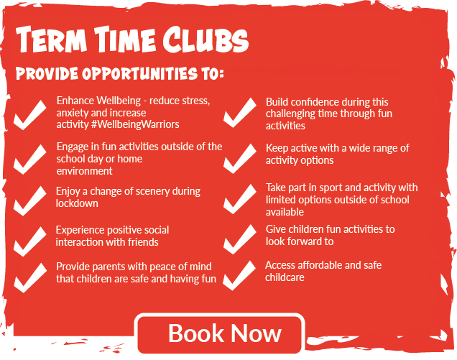

Has your child got what it takes to become the ultimate Wellbeing Warrior? With lockdown upon us - we are taking children’s wellbeing into our own hands by once again, providing opportunities to experience a shelter of positivity as we encourage all families to become Energy Kidz #WellbeingWarriors.
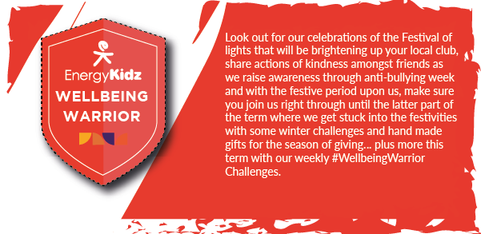

Here at Energy Kidz we understand that these are challenging times to keep children entertained, active, and engaged – whether this be during the week or at the weekend and therefore we are delighted to be here with some activities you may wish to take on! Join us before and after school weekdays or try these at home!
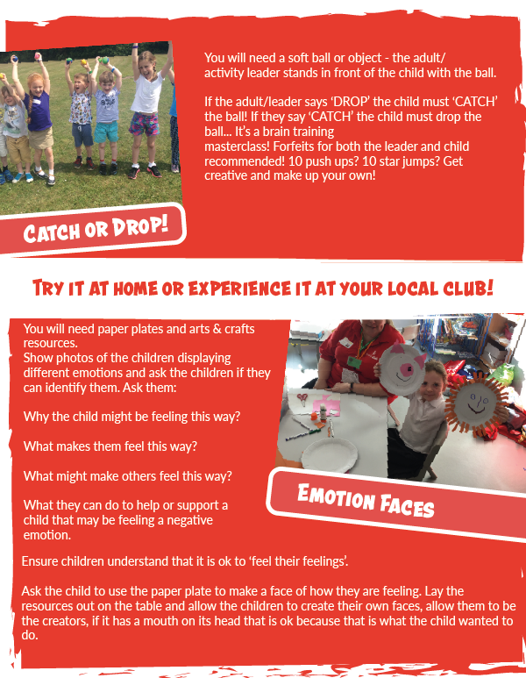
Energy Kidz are delighted to announce that our Winter Clubs are now available to book at a number of our host venue schools. This Winter Holidays, we want to provide children with something to look forward to post lockdown as we promise to be delivering a few weeks of jam-packed activities that are safe and engaging for all children. Let us be your child’s safe space this Winter and book now!
We are excited to announce that we have already confirmed a number of Winter Holiday Club venues and they are available to book now! We are committed to provide children with an another highly anticipated holiday to remember with our Winter Clubs. You can find your nearest venue at: https://www.energy-kidz.co.uk/holiday-club/
Give your child something to look forward to this Winter and Claim a cool 10% off your local Winter Camp booking by using code: EBWINTER10
Please note – we plan to run all of our venues listed, however if due to the current climate a venue has to be cancelled parents will be provided with a full refund.

Booking Information & FAQ’s

Secure your child’s place for the Autumn term! Bookings are now open across the Term Time School Club with spaces filling fast – don’t miss out!
Parents can book online at https:/bookings.energy-kidz.co.uk/Identity/Account/Login where they will need to create an account if they haven’t already. Once created you can select your school club at book your required days!
Booking Help Required? Check out our helpful video tutorials which ensure securing your child's spot is a quick and easy process!
WATCH: How to create an account
WATCH: How to make weekly bookings
WATCH: How to make an ad-hoc or regular booking

If you have any queries or would like any further assistance with account creation or registering your child(ren) please do not hesitate to get in touch with us info@energy-kidz.co.uk, or alternatively call our friendly customer service team on 0333 577 1533.

